Hydrazones with Functional Diversity:
Supramolecular Assembly, Chirality Control and Aggregation Induced Emission
Kyung-su Kim, Hye Jin Cho, Hyunwoo Kim and Changsik Song*
Department of Chemistry, Sungkyunkwan University, Suwon, Gyeonggi 16419, Korea
E-mail: songcs@skku.ac.kr

Stimuli-responsive or controlled self-assembly has been intensively investigated over the years for various applications such as bio-sensing, drug delivery and actuators. Hydrazone functional groups have advantage to be applied in such materials due to their dynamic property of the reversible C=N bond. In this talk, novel hydrazone derivatives were discussed, which show concentration-dependent equilibrium of a hydrazone and its dimer or aggregates. This phenomenon was also affected by protonation/deprotonation equilibria. The self-assembly of those hydrazones could be controlled not only by pH variation, but also by dynamic covalent exchanges. In addition, the introduction of a chiral auxiliary group gave rise to the supramolecular chirality, which can be controlled by kinetic or thermodynamic conditions. Lastly, it was discovered that certain hydrazone derivatives showed aggregation-induced emission (AIE). Its origin will be discussed in terms of their molecular structures.

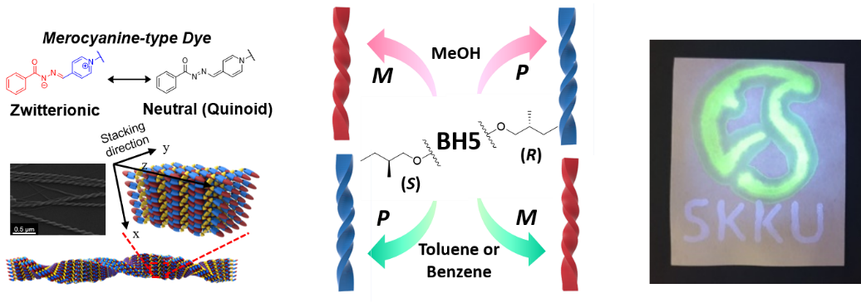

Figure 1. Functionally diverse hydrazone derivatives: pH-dependent supramolecular assembly, chirality control, and aggregation-induced emission.

